🌳 Wardrobe Mirror – Final Decision Tree (Item-Based)
🟢 Entry: Item Prompt
(Show image of garment- Randomly displayed)
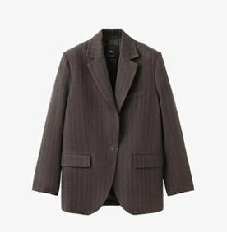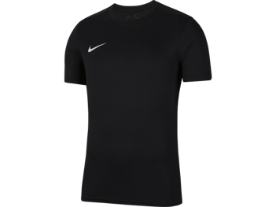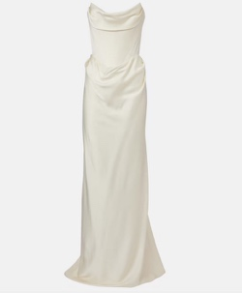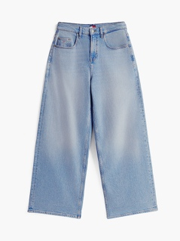

Q1. Do you own something like this?
- Yes, and I wear it often → Active Path (A)
- Yes, but I rarely wear it → Low-use Path (B)
- No → Show next item
🟢 A. Active Garment Flow

A1. Price
About how much did it cost?
- Free
- €1–20
- €21–50
- €51–100
- €100+

A2. Frequency (optional if already captured)
How often do you wear it?
- Daily
- Several times a week
- Weekly
- Monthly
A3. Age
How long have you had it?
- Less than 3 months
- 3–12 months
- 1–2 years
- 2–5 years
- 5+ years
A4. Inflow (Acquisition)
How did you get it?
- Bought new
- Bought second-hand
- Gift
- Borrowed / shared
- Made it

A5. Care
How do you usually care for it? (select all that apply)
- Machine wash
- Hand wash
- Dry clean
- Air dry
- Tumble dry

A6. Repair
Have you ever repaired it?
- Yes, myself
- Yes, professionally
- No, but I would
- No

→ End of item → Continue or Exit
🟡 B. Low-Use Garment Flow
B1. Price
About how much did it cost?
B2. Age
How long have you had it?
B3. Inflow
How did you get it?
B4. Why don’t you wear it often?
- Doesn’t fit
- Out of style
- Seasonal
- Forgot about it
- Other

B5. Reactivation
Would you wear it more if… (select all that apply)
- It fit better
- It was repaired
- I styled it differently
- I was reminded of it
- No, probably not

B. Future Plan
What will you likely do with it?
- Keep it
- Repair OR Repurpose
- Gift OR Donate
- Sell it
Throw it away
🔴 C. Discarded Items Flow (Optional but Valuable)
(Can be triggered separately or after main loop)
C1. Have you gotten rid of something like this before?
- Yes → continue
- No → skip

C2. Why did you stop using it?
- Worn out
- Damaged
- Didn’t fit anymore
- Out of style
- Lost interest
- Other

C3. What did you do with it?
- Threw it away
- Donated it
- Sold it
- Recycled it
- Gave it to someone

🔁 Loop / Exit
Nice! Want to try another item?
- Yes → New garment
- No → End

